Chapter 11- Mandelbrot Set

"The Mandelbrot Set is the most complex object in mathematics; its admirers like to say. An eternity would not be enough time to see it all, its disks studded with prickly thorns, its spirals and filaments curling outward and around, bearing bulbous molecules that hang, infinitely variegated, like grapes on God's personal vine."
[James Gleick, "Chaos: Making a New Science"]

There is beauty in mathematics. You just need to look in the right place. [ Anonymous]

11.1 Introduction
Benoit Mandelbrot (1924-2010), a Polish-born French mathematical physicist, who was working with IBM, developed the field of fractal geometry which played a key role in the emergence of chaos theory. He did most of his pioneering work in the 1970s and published his findings in an illustrated and erudite book called Fractals: Forms, Chance and Dimensions. No one understood what he was on about - largely because the prose was difficult to fathom. In 1977, a much-refined version of that book was republished as The Fractal Geometry of Nature - and fractal geometry caught the imagination of scientists.
Ever since Mandelbrot popularized fractals, students of mathematics have been intrigued by the theory behind them. Likewise, students of computer science, and especially computer graphics, have been engrossed in the beauty of fractal images.

The Mandelbrot Set is a set of complex numbers c that exhibit an interesting behaviour when run through a simple recursive formula $z_{n+1}={z_{n}}^{2}+c$ where$z_{0}=c$ . When this formula is applied repeatedly (with the result from one calculation used as the input to the next calculation), numbers within the Mandelbrot set will, converge towards 0+0i (the origin of the complex plane) or oscillate around 0+0i. Numbers not in the set will, after some number of iterations, diverge away from origin. The complex numbers that "escape" or “diverge” are not in the Set, but they are the interesting values when making images. The basic technique is to use the number of iterations required to make the modulus of number escape (exceeds a certain value , usually 2 ) as an index into a colour table and to colour the position C (complex number representing a point in complex plane) based on colour index and colour those points C which are inside the set as plain black.
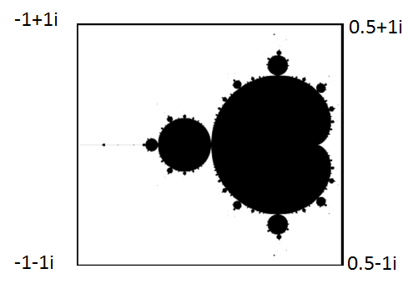
Fig 11. 1 a) Mandlelbrot b) Mandelbrot set in complex plane
Figure 11.1 shows the picture of Mandelbrot. Right figure shows location of the Mandelbrot set in complex plane. The black points are elements of Mandelbrot set. Figure 11.1c is a coloured rendering of the iteration result.

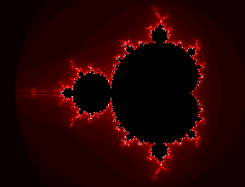

Figure 11.1 c) Coloured rendering of the Mandelbrot set.
11.1.1 Mathematical definition of Mandelbrot set
The Mandelbrot set is a set of complex numbers defined in the following way:
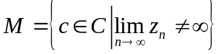
Where 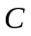 is the set of complex numbers ;
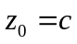 ; 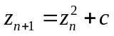

That is, the Mandelbrot set is the set of all complex numbers which fulfil the condition described above, that is, if the value of the (recursive) function 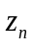 for the value c is not infinite when n approaches infinity, then c belongs to the set.

11.2 How to plot Madelbrot set
The algorithm for defining the set is really quite simple.
- Let $c$ be a complex constant representing a position on screen (real part x and imaginary part y as a pair (x,y) represent a point on the screen).
- Let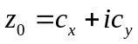 be starting value of iteration.
- Iterate once by letting $z_{n+1}={z_{n}}^{2}+c$
- Repeat step 3 until one of the following occurs:
  - The modulus (length) of $z_{n}$ exceeds a given value (here we take 2 since if once modulus of $z_{n}$ exceeds 2, in subsequent iteration, modulus become larger and larger). This is our test for divergence.
  - The number of iterations exceeds a given value (usually 128). This is how we assume convergence.
- Draw the point with color determined by the number of iterations. Often one uses the following equation : Color_index = (n mod 16 ) +1 where n is the number of iteration taken to diverge and “ mod” represent modulo operation.
The above equation assumes the use of 16 colors with color_index ‘0’ meant for the color for coloring the points which fails to diverge for the chosen iteration limit. It must be noted that choosing the proper color palette and the decision on how to choose color index for a given count of iterations to diverge (say n) is paramount importance in getting exotic looking fractals.
Figures 11.1 c) shows one rendering. As said earlier, there are different ways to choose colors and depending on that, figure appears differently. The boundary of the Mandelbrot set hides astonishing details. If the computation-area chosen is near boundary, the resulting figure shows fantastic patterns like the one shown below (with careful choice of the pallet).
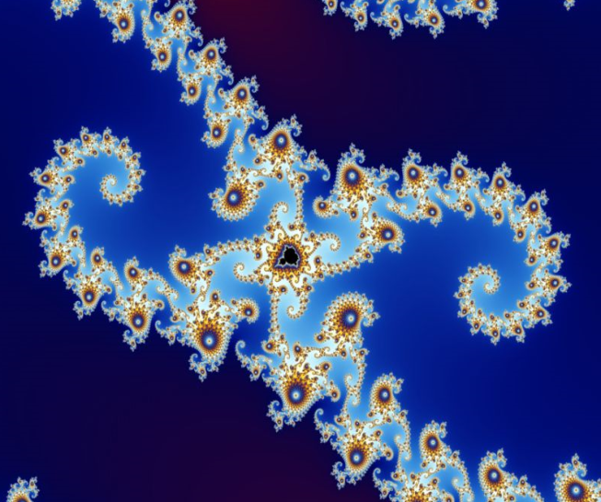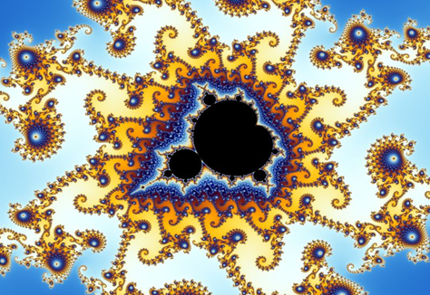
Figure 11.1d Figure 11.1e
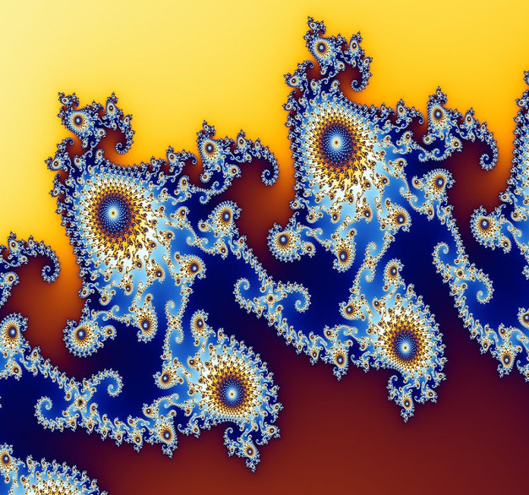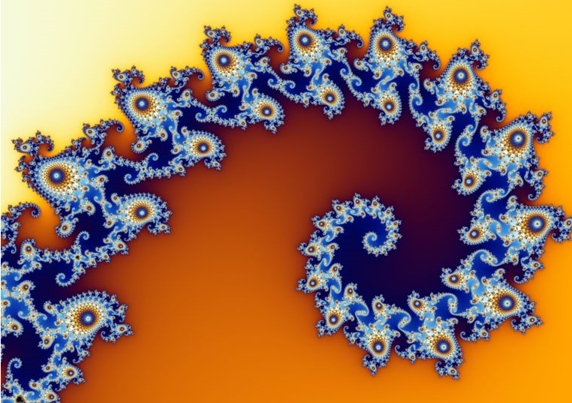
Figure 11.1f Figure 11.1g
11.2.1 Good, Bad and Ugly
One common problem with webpages which present zooms of the Mandelbrot set is that usually the people who have made them pay little to no attention to the color palette used in the images. This is why you so often see really ugly Mandelbrot set images like the one below (Figure 11.1 h).
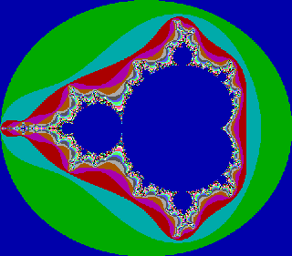
Figure 11.1h An Ugly plot of Mandelbrot set
This is often because people use very limited Mandelbrot drawing software which have very low-quality color palettes (often limited to just 256 colors), and even when some software support better palettes, people are too lazy to search for good ones and instead just use the default palette offered by the program. Another common problem is that people don't explore the set enough nor try to find truly marvelous zooms of it.
This is quite sad. The true beauty of the Mandelbrot set is destroyed with poor color palette choices and lack of enough exploration.
The XaoS fractal drawing program is excellent software which can zoom into the Mandelbrot set in real-time and can produce stunningly beautiful color pictures. XaoS is a free software, licensed under the GPL.
Here are some interesting parts of the Mandelbrot set that is made with XaoF fractal drawing program.
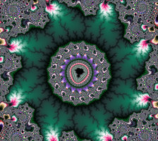

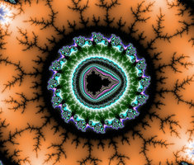

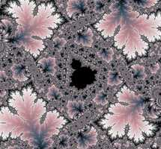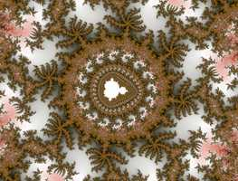

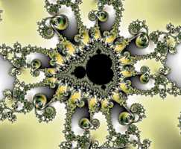



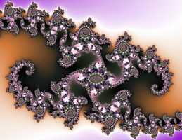
Figures 11.1i to z : Part of Mandelbrot Set drawn with carefully chosen color pallette.
11.3 Strategy used to draw Mandelbrot fractal in Excel
In Excel we form a grid as shown in figure. Note that each cell in the grid now gets a coordinate (x,y). We assume now this as a complex plane. So each cell’s address is a complex number x+iy. So the address of the darkened cell in the grid is -0.2-0.4i.
This act as c in the iteration . For each cell we do an iteration to decide its colour.
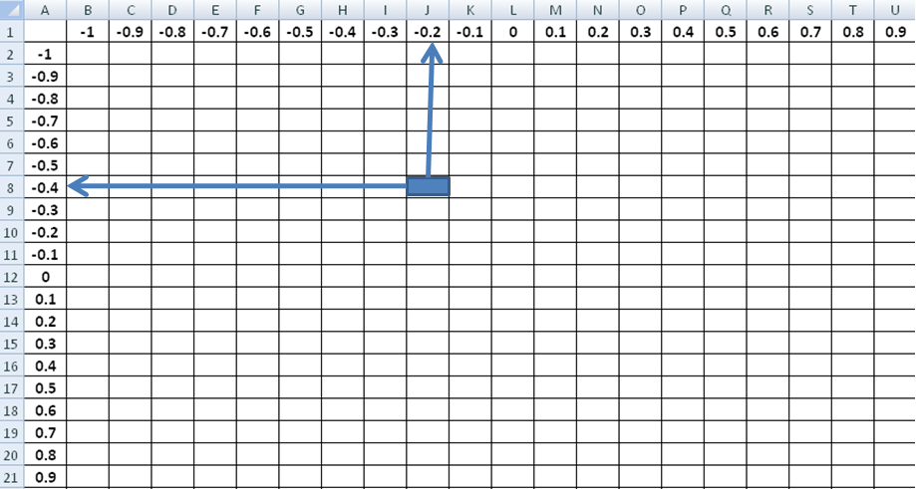
Figure 11.2 Excel acting as a point in Complex plane
Once we get color for each cell we can reduce the cell size to that of a pixel so that we see the pattern as a high resolution image. The question now is how to do the iterative computation for each cell. Again Excel’s What-if Utility helps us. We show one example iteration to excel for deciding the color and then handover What-If analysis utility to take care of remaining computation.
11.3.1 Computation involved

Let 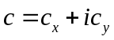 . Let the starting value for all cases be 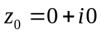

Or 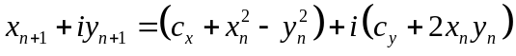
Therefore 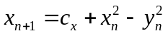 ( 11.1)

and 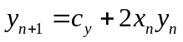 (11.2)

We iterate this 32 times (for high precision we may use higher number of steps) and check the square of the magnitude of the complex number 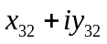. If it is less than 4 , we colour the cell corresponding to as black. Other wise, colour it according to number of iteration taken to diverge.

Experiment No:1 Draw Mandelbrot fractal with two colours.

Step 1: enter Title strings
In cells A1 to A8 enter the string “n” , “Cx”, “Cy”, “xn”, “yn”, “Diverged?”, “Count”, “Colour”
Step 2: Generate index of Iteration in a row
In B1 and C1 enter 0 and 1. Select them and drag till AH1 . The values in this cell represent iteration number.
Step 3: Enter real and imaginary part of complex number “c”.
In B2 and B3 enter 0.1 . These values represent the real and imaginary parts of parts of complex constant “c”. (You may format this cell to give some colour as it represents variable cells of What-If analysis.
Step 4: Enter starting values of iteration. (For Mandelbrot set it is c_{x} and c_{y}).
Enter =B2 in the cell B4 and =B3 in cell B5. These values represent real and imaginary part of starting point of iteration.
Step 5 : Enter Iteration Formula (for updating x-value).
Enter =$B$2+(B4-B5)^2 in cell C4. This is according to the formula . Note the dollar sign for B2. This cell value represents Cx . It should be constant through out the iteration.
Step 6 : Enter Iteration Formula (for updating y-value).
Enter =$B$3+2*B4*B5 in cell C5. This is according to the formula. . Note the dollar sign for B3. This cell value represents Cy. It should be constant through out the iteration.
Step 7: step for 32 Iterations
Select cells C4 and C5 and drag the fill handle till AH5.
Step 8: In each iteration, check whether 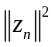 is diverged or not.
Enter =if(C4^2+C5^2>4, “YES”,”NO”) in C6 and Drag till AH6.
Step 9: Count number of “No”s in row 6 ( in the output of step 8)
In cell B7 enter =countif(C6:AH6,”NO”)
Step 10: Decide the colour of cell representing the point 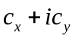 . If the count in step 9 is 32 it means that the iteration did not diverge. In that case, we give colour value as 0 . Otherwise, give colour value as 1.
Enter =if(B7=32,0,1) in cell B8 .
Now we have completed one iteration.
Step 11 : Prepare Table for What-if Analysis.
Most of Mandelbrot set is in the range -2 to 1 along both x and y axis
In Cell B8 and C8 enter -2 and -1.95 respectively. Select these two cell and drag till BJ11
In Cell A12 and A13, enter -2 and -1.95 respectively. Select these two cell and drag till A72
In Cell A11 (the corner cell of the table) enter =B8 (this corresponds to colour index for the example iteration).
Step 12: Use of What-if Analysis for computing colour index for different combination of x-y coordinates given by the Data-Table in step 11.
Select Cells A11:BJ72 and go for what-If Analysis. Choose Row-input cell as B2 and Column-input cell as B3. The output (partial) look as follows in Figure 11.3 a

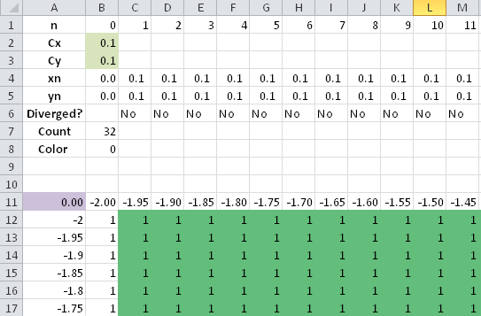

Figure 11.3a Snapshot of What-If Analyis for Mandelbrot fractal

Step 13: Conditional formatting for colouring the cell
Select the cells in tables starting from B12 and ending in BJ72 and go for conditional formatting (available at the ‘home’ Tab in Excel-2010) and choose any one of the three colour palette. A part of the excel sheet look like this

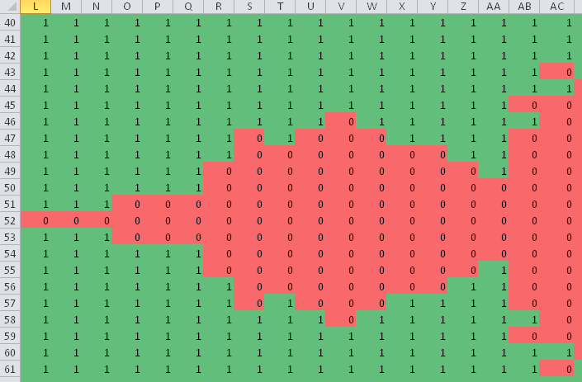
Figure 11.3b Snapshot of Mandelbrot fractal obtained after conditional formatting

Step 14: Reduce the cell Size
Select columns A to BJ , right click the mouse and choose Colum width. Give column width as 0.1
Select Rows A12 to 73 , right click the mouse and choose Row height. Give Row-height as 1. The output looks like this (Figure 11.3c).

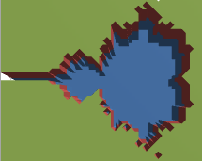

Figure 11.3 c) Mandelbrot fractal by conditional formatting d) Mandelbrot fractal by surface plot

Step 15. Select Cells B12:BJ72 and go for surface plot. From the plot remove unwanted objects like axis, grids and labels. Select the plot area, Right click the mouse and go for 3D rotation. For rotation about x axis as 0 degree, rotation about y-axis as 90 degree and perspective as 20 degree, the plot look as in Figure 11.3d.

Experiment No: 2 Get surface plot of Mandlelbrot set with color-index given to a cell is same as number of iteration taken to diverge.

In the excel sheet where experiment No: 1 is done, make the following changes

Step 1: In the cell A11, enter =B7 . Note that B7 contain the formula for getting count of number iteration taken to diverge. Excel automatically updates the table values. No need of of doing what if analysis again!.

Step 2: Select the cells from B12:BJ72 and go for surface plot. Remove labels, axes, grids etc. from the plot object. Placing the mouse pointer inside the plot area and right click the mouse and choose 3D rotation. A figure like this can be easily obtained.

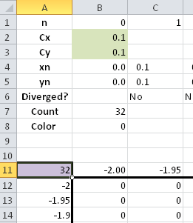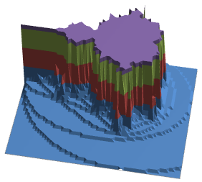

Figure 11.3e : Snapshot of excel sheet. Figure 11.3f : elevated Mandelbrot set.

Experiment No: 3 Get surface plot (wireframe contour) of Mandlelbrot set with color-index given to a cell is by the formula (n mod 8 ) where n is the number of iteration taken to diverge.

In the excel sheet where experiment No: 1 is done, make the following changes

Step 1: In the cell A11, enter = mod(B7,8)

Step 2: Select data and go for surface plot . Within surface plot, there are four options. Choose the last option.

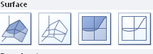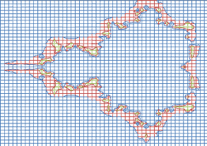

Figure 11.3g : Surface plot options. Figure 11.3h : Wireframe contour plot

11.4 The Julia set
One cannot study the Mandelbrot set without hearing about the Julia set as well. Almost always when the Mandelbrot set is discussed or explained, the Julia set is also mentioned. This document is no exception. Julia sets are named after Gaston Julia, the French mathematician who discovered them and first explored their properties. He lived from 1893 to 1978 and his masterpiece on these sets was published in 1918 (Julia).
So what is the Julia set and what is it relation to the Mandelbrot set?
Many people have seen Julia sets like this:

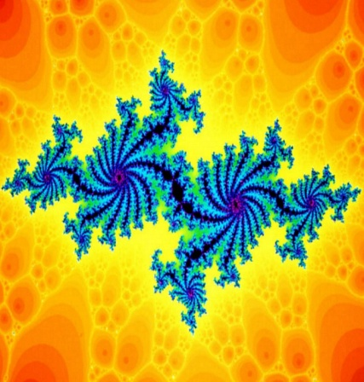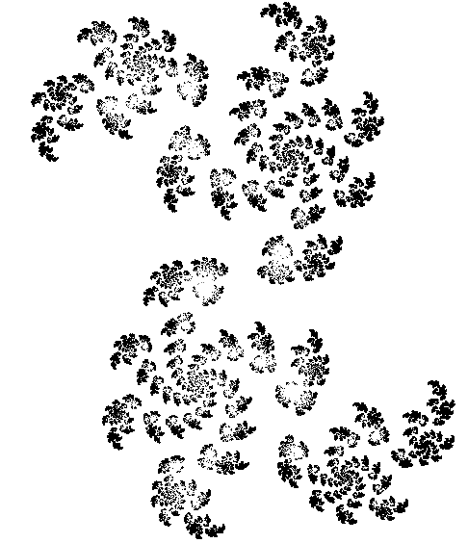

Figure 11.4a Julia sets
Julia sets can be quite pretty, but their connection to the Mandelbrot set is not clear.
The first connection is the mathematical definition of the set. It's almost identical to the Mandelbrot set:
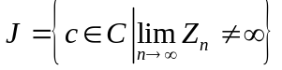
where: 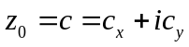
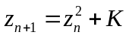
The only difference to the Mandelbrot set is that the generic function is not "", but " ", where K is some chosen (constant) complex number.
This means that although there is only one Mandelbrot set, there are many Julia sets (actually an infinite amount), one for each possible K (i.e. one for each complex number).
So what's the connection between the Julia set and the Mandelbrot set besides their formulas being almost identical?
The value of K has a quite interesting relation with the Mandelbrot set:
- If K is inside the Mandelbrot set, then the Julia set for K will be connected. If K is outside the Mandelbrot set, then the Julia set for K will be disconnected (that is, it will have at least two disconnected "islands").
- If we choose a K from inside the Mandelbrot set, its location inside the set will have a radical influence in the shape of the respective Julia set. The closer K is to the border of the Mandelbrot set, the "thinner" and more "whirly" the corresponding Julia set will be. If we choose a K farther away from the border, the respective Julia set will be "thicker".
- If we choose a K which is very close to the border of the Mandelbrot set, there will also be a close relation between the shape of the Julia set and the shape of the border of the Mandelbrot set at that place. Zooming in the Mandelbrot set around K will bring up shapes that look like the Julia set for K.
For these reasons it is said that the Mandelbrot set is a "map" of all the Julia sets.
Figure 11.4b shows a 3D rendering of a Julia set.

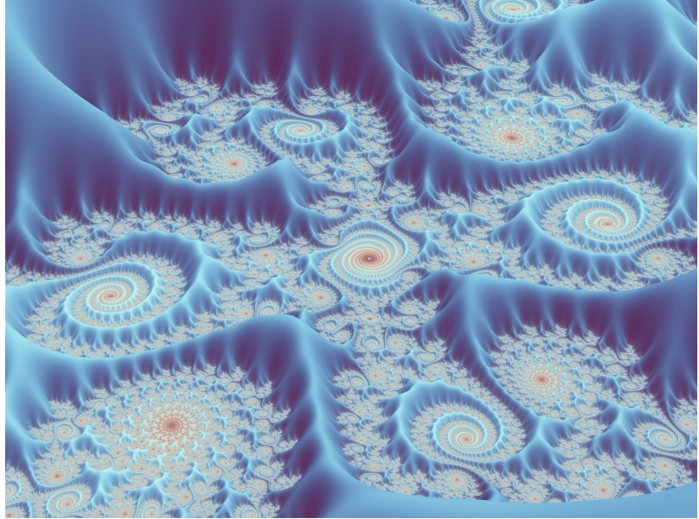

Figure 11.4b A 3-dimensional Julia set (source: Wikipedia)

11.4.1 Plotting Julia set in Excel

Experiment No:4
Julia set requires the same type of computation as Madelbrot set. A slight modification in the Excel sheet where we did calculation for Mandelbrot set will draw the Julia set. For covenience we have shown the excel sheet again in Figure 11.5a. In Julia set, complex number K assume the role of complex number c in the iterative equation for Mandelbrot set . Therefore

Step 1: in cell B2 and B3 enter real and imaginary part of K.
Step 2: in cell B4 and B5, enter any starting values. The main change is in step 3
Step 3: Select the data table (A11: BJ72) and go for What-If analysis. It will ask for Row Input Cell and Column input cell. For Julia set, we give cell B4 as Row input cell and B5 as the column input cell. See figure 11.5a . Note that for Mandelbrot set , we had given cell B2 and B3 as the row and column input cell respectively. Rest of the process is same. See Figure 11.5b.

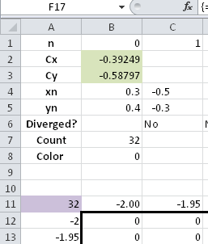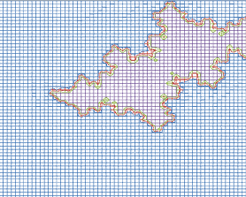

Figure 11.5a Excel data sheet Figure 11.5b Wireframe contour plot of Julia set

11.5 General high resolution Implementation using Complex number formulas in Excel

Workbook: Fractal/Finished Works/Worksheets/Mandelbrot/Unexpanded/Mandelbrot Fractal 1024 64 iter

The implementation is given both in the CD along with the book. The implementation is similar to that of Newton Fractals in the previous chapter. Since Mandelbrot Fractal was the first of its kind, we are going to give due respect and create a high resolution Mandelbrot from scratch.
Open a blank workbook and enter the parameters according to Fig 11.6. Xres and Yres are resolution parameters for X and Y. This is used for the data table and the final picture resolution which is followed by the coordinate system limits in Xmax, Ymax, Xmin, Ymin. MaxIT is the maximum iterations to be done for each coordinate point. DeltaX or C11 is calculated using the formula (Xmax-Xmin)/Xres or in terms of excel formula = (C6-C8)/C4. Dragging this down to C12 will calculate DeltaY. Maximum value for the absolute values to expand is given in Max val.

The Coordinate limits i9n Xmax, Ymax, Xmin, Ymin are taken by adjusting after fractal generation. It can be taken as 2, 2,-2,-2 to have the feel of how it looks to start with.

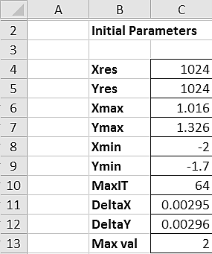
Fig 11.6 Parameters for drawing Mandelbrot set

You may have to manually calculate the cell limits. We can also take the help excel to do the job for us. In our case the column starting for the data table is G. Row number for G is 7. The last value for the data table can be calculated by using the formula =ADDRESS (20, 7+1024). This displays the output as $AMQ$20. So we are going to use the limits from G21 to AMQ1045. G20 to AMQ20 is going to have the X-coordinate values and F21 to F1045 contains the Y-coordinate values.

We are going to create a coordinate system like the real system. So F21 will contain Ymax and G20 will contain Xmin. F22 contains the next lower Y value given by F21-DeltaY. H20 contains the next higher X value given by G20+DeltaX. The formula for each of these cells is given in Fig 11.7. The figure was modified to display all the formulae together.

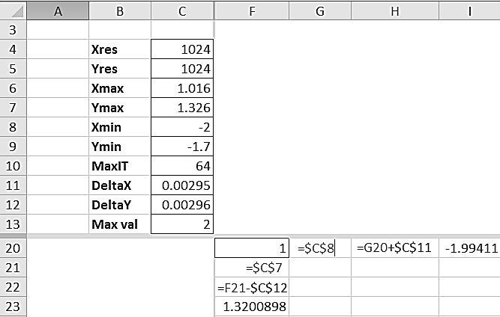
Fig 11.7

Once the formulae are entered, select the cell H20 and press Ctrl+C. Now click on Name Box and enter I20:AMQ20. This will select the 20th Row from I to AMQ. Press Ctrl+V. This pastes the formula on all these cells. This is an easy way compared to dragging long ranges. Similarly Select F22 and Press Ctrl+C. Click Cell Adress Bar and enter F23:F1045. Press Ctrl+V. this copies the formula down to F1045. Now the Data table for the coordinate system is ready.

11.7.1 Iteration with Excel

We start the iteration from G10 and the limiting cell for the iteration is taken as BR10. For convenience, this has been calculated in G15 as =ADDRESS(10,COLUMN()+$C$10-1). This gives the iteration ending cell based on Maximum iteration given in cell C10.

In Fig 11.8 Cx and Cy are the real and imaginary part of the ‘c’ in Mandelbrot equation. These cells are temporarily pointing to G20 in H5 and F21 in H6.

The formula to be entered in G10 is given in the formula bar above. Let us see now what this means.

=IMSUM(IMPOWER(COMPLEX(0,0),2),COMPLEX($H$5,$H$6))

- COMPLEX(0,0) defines Z₀ which is essentially 0+i0
- IMPOWER(COMPLEX(0,0),2) defines Z₀²
- COMPLEX($H$5,$H$6) defines ‘c’ which is Cx+iCy
- Finally the formula calculates Z₀² + c

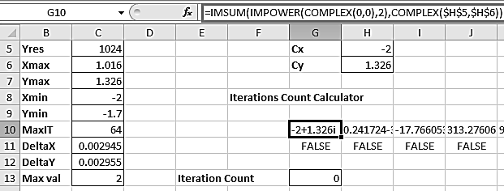
Fig 11.8

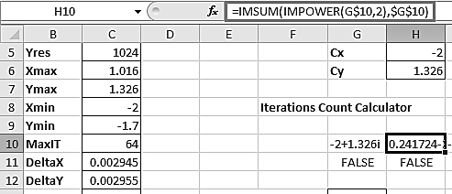
Fig 11.9

G10 now contains Z_{1.} H10 calculates Z₂ with =IMSUM (IMPOWER (G$10, 2), $G$10), which is essentially Z₁² + c
Copy the formula from H10 till BR10. This now becomes the iterative loop.
Now, G11 contains the formula =IF (IMABS (G$10) <=$C$13, TRUE, FALSE). This checks whether the absolute value of G10 is less that Max value and accordingly define True or False.

G13 contains a count of True values from G11 till BR11.

11.7.2 What-if Analysis

In simple terms, what-if here can be described as – what if a certain X and a certain Y are given.
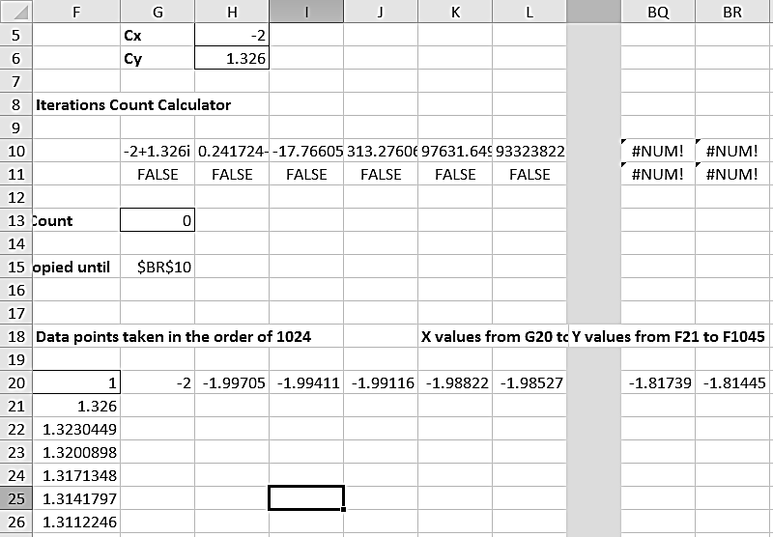
Fig 11.10
Look at Fig 11.11. It can be seen that I24 has to be calculated and what-if puts the value of F25 to H6 and I20 to H5. Once the value of H5 and H6 changes, the entire iteration values changes from G10 to BR10. And hence G11 to BR11 also changes with finding True or False. G13 calculates the count of Trues and this value goes to F20, which is the pivot of the data table. For colouring convenience, F20 has a formula =MOD (G13, 3) +1. This varies the values within 1, 2, 3 which is ideal for colouring. This value is put onto I25.
A flow diagram of What-if is given in Fig 11.11. For a better diagram flow, the cells are vastly rearranged. For actual reference please refer the Mandelbrot worksheet that comes along with the accompanying CD which is referred in Fig 11.10.
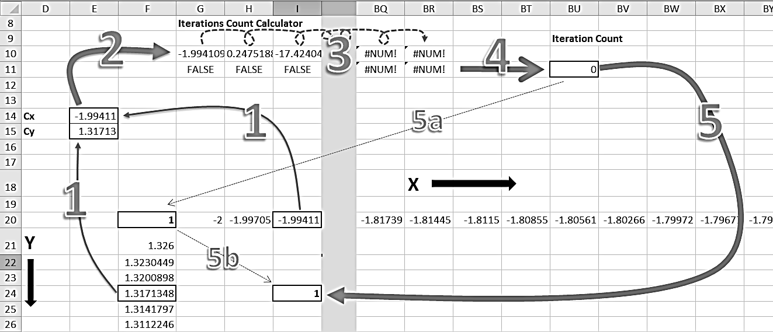
Fig 11.11

Step1: The row value and the column value goues into Cx and Cy, which is the ‘c’ part of the Mandelbrot equation.
Step2: Cx and Cy is used by the iterative procedure for the first value which is basically z=c
Step3: the iterative procedure, where z_{n+1} is calculated and continued onto the next cell as z_{n} The second row in step 3 is used to find whether the calculated values overshoots the absolute value.
Step4: The total number of iterations used until divergence are counted by counting the number of TRUE values.
Step5: This iterative count is used for the value in the intersection cell of the row and column value taken. This is actaully done in two steps where Step5a takes it to the pivot, where we normally adjust the numbering for effective colouration by modulating it. Step5b is an automated step which move the value in the pivot to the intersection cell.

This process takes time in the scale of minutes. For a 2 vcpu windows xp 64bit virtual machine, it takes about 3 minutes. Office 2010 can make full utilization of the cpus available to the OS.

Once the values are generated, it is better to copy them to another sheet for drawing the fractal. What we have done is linking to another sheet, so that any change to parameters gives direct results. But there is a downside to this. Any change in paramater results in a long wait of about 6-8 minutes to complete the operations. So it is adviced to establish a fractal with resolution 100 and then experiment.

Switch to Sheet2 and in cell G21, enter =Sheet1!G21. this links the cell contents to Sheet2. Press Ctrl+C. Now click in the Name Box and enter G21:AMQ1045. This selects the entire Data range. Press Ctrl+V. With a short delay, the entire set of cells will be populated with numbers. Now select Conditional Formatting from either Home menu (Office 2010) or Format menu (Office 2000). Follow the procedure as in Fig 11.11.

This colours the cells according to their numbers.
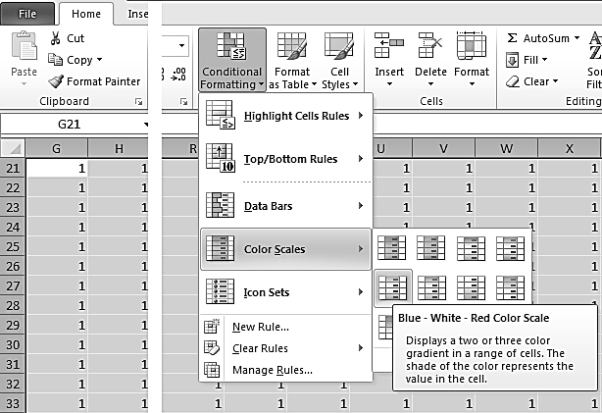
Fig 11.12

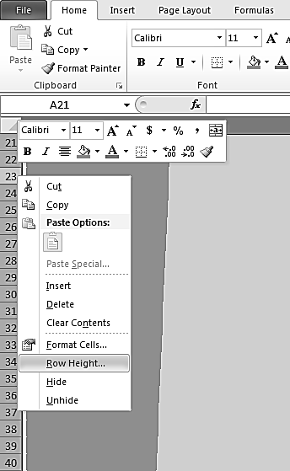
Fig 11.13
Now that colouring is done, it is time to define cell size. In the Name Box, type G: AMQ. This selects the columns from G till AMQ. Right click on any top column name row and select ‘Column Width’. Give the value as 0.1. The manner of setting the same for rows is given in Fig 11.12. For selecting the rows type 21:1045 in the Name Box. Set the row height as 1.

There you go. Unless you have not made any mistake while typing the formulae, you will be getting a beautiful Mandelbrot fractal like in Fig 11.14 or with some modifications in Conditional Formatting - Fig 11.15., that too in spreadsheet, without touching any programming – Macros.
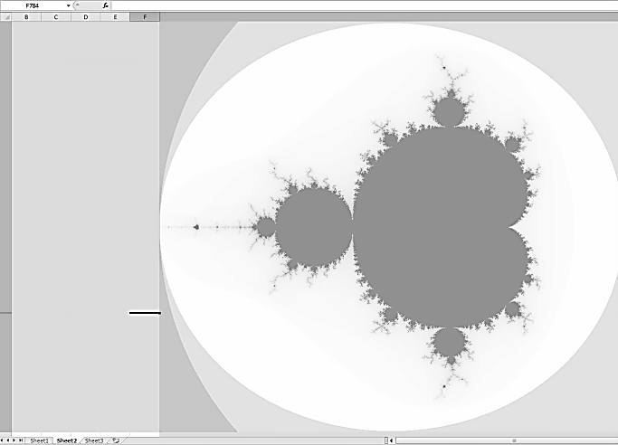
Fig 11.14
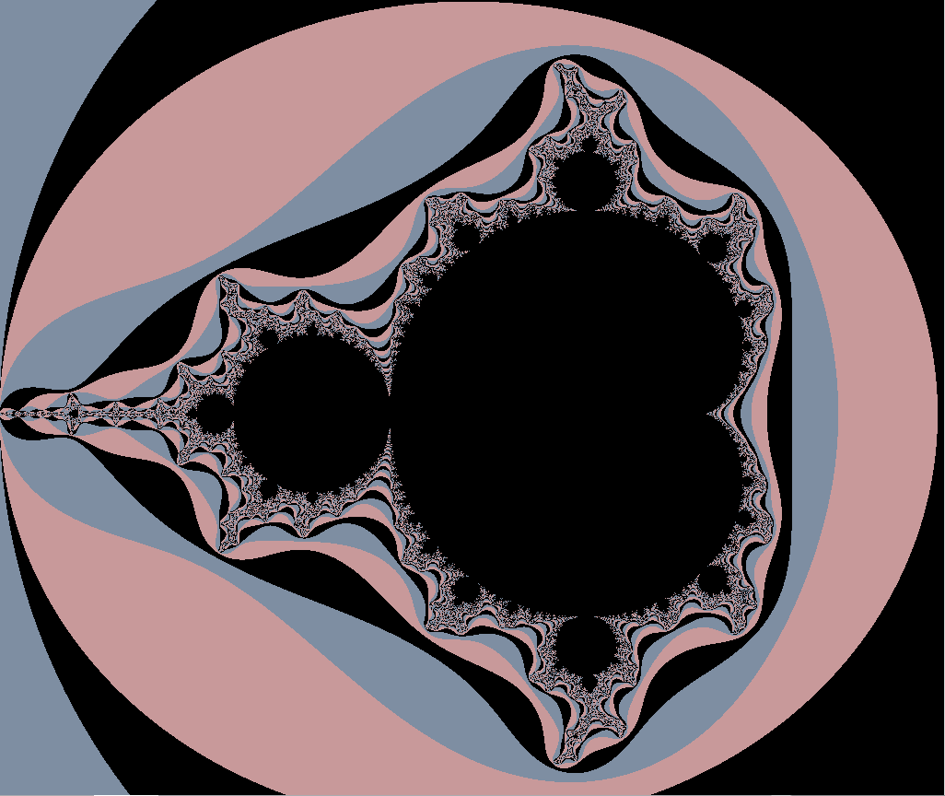
Fig 11.15

11.8 Implementation of Julia sets
Workbook: Fractal/Finished Works/Worksheets/Julia Set/Unexpanded/Julia Set1 1024 and 28 iter
The implementation of Julia Set is very similar to that of Mandelbrot. We shall start with Julia Set 1 from the CD given to you along with the book. We have added some information about the resolution and number of iterations in the filename itself. The what-if analysis takes quite a bit of time in older machines and may not work in older versions of MS office owing to the size of the calculations. This is better done in Excel 2010.
The parameters are similar to that of Mandelbrot. We add two more cells in the name of Cx and Cy to represent that they are non-changing cells. It looks like the figure below. Notice C13 and C14. Also notice H5 and H6 which now hold the value for Z in the form of x and y.
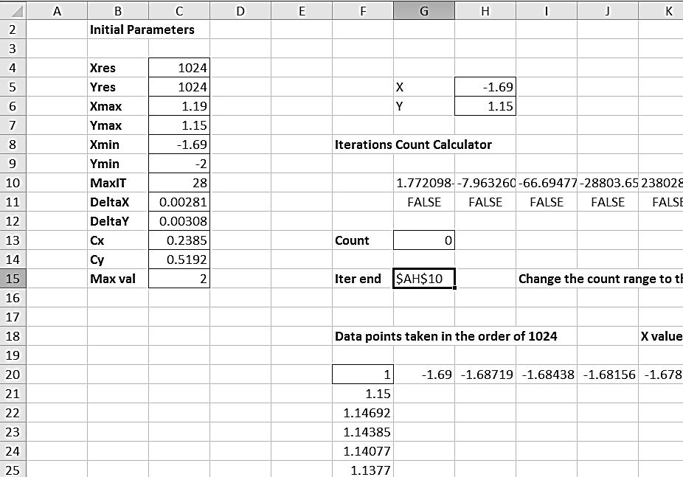

The formula in the iteration block from G10 to AH10 also varies, this time to handle the Julia specific variation of the Mandelbrot equation.
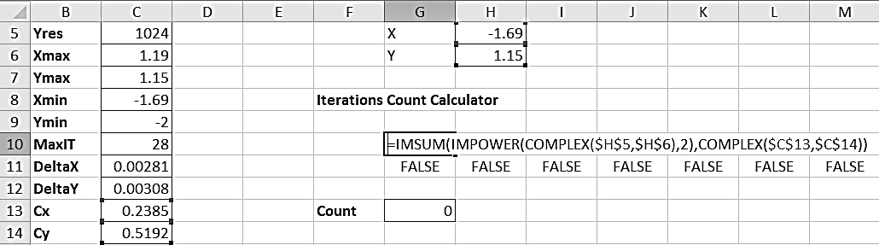
=IMSUM (IMPOWER (COMPLEX ($H$5, $H$6), 2), COMPLEX ($C$13, $C$14)). This formula is finding (X+iY) ²+ (Cx+iCy) in cell G10. This is our Z₁. In the next Figure below, you can find the formula for Z₂. =IMSUM (IMPOWER (G$10, 2), COMPLEX ($C$13, $C$14)). This is simply Z₁²+C and the formula continues until AH10. We are taking only 28 iterations in this case. You can also find a 128 iteration file in the same location in the CD. This takes more time but delivers even detailed image of the same Julia Set.
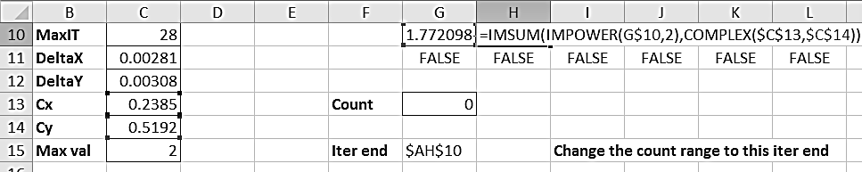
Rest of the operations of finding the number of iterations taken to diverge, using what-if to generated the data points, linking the cell values to Sheet2 and finally colouring using conditional formatting is same as in Mandelbrot or Newton Fractals. The colouration schemes shall be anything according to your colouring sense. The number generation in F20, the pivot cell, can be done with =G13+1 or =MOD(G13,3)+1 or =IF($G$13+1>=$C$10,1,MOD($G$13+1,52)+2). The first one is simple and faster in calculation, but gives a more subtle colouring. The second one is ideal for research and study work as it gives an extreme detailing of the Julia set with just three colours. The third one was what we have used. You can see all these usages throughout our files. Vary the parameters for C as follows [Ref] and you can generate Beautiful Julia Sets like the ones below.
Cx | 0.238498 | -0.74304 | -0.19218 | 0.108294 | -0.39249 | 0.138341 | 0.27856 | -1.25884 | -1.02848
Cy | 0.519198 | 0.113467 | 0.656734 | -0.67049 | -0.58797 | 0.649857 | -0.00348 | 0.06533 | -0.26476

Cx | 0.318623
Cy | 0.044699

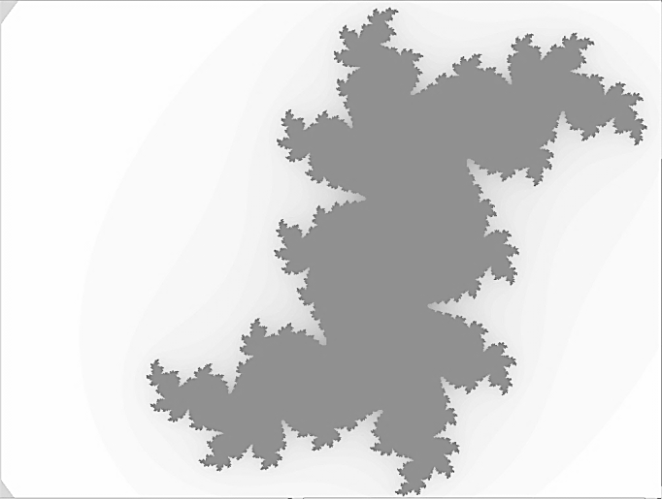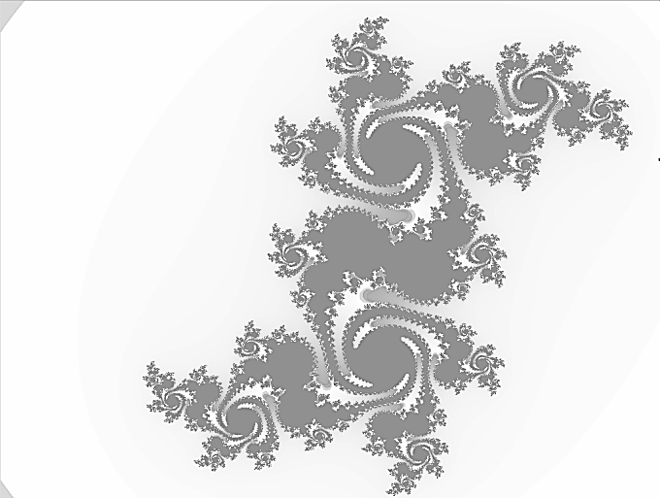

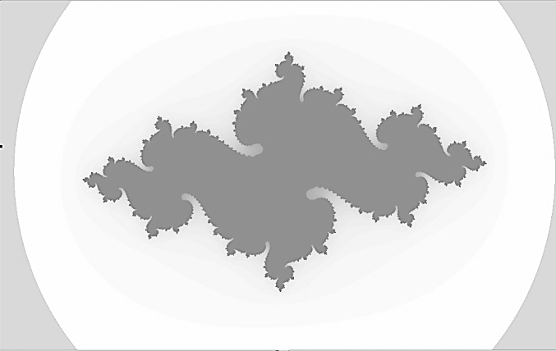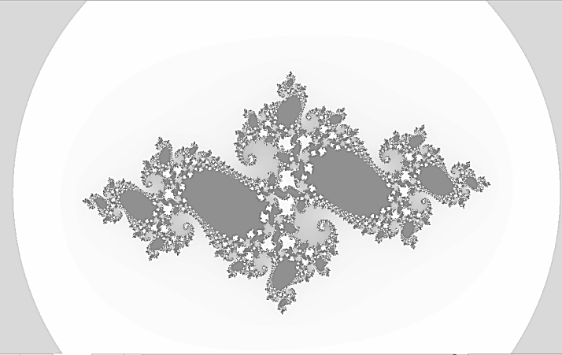

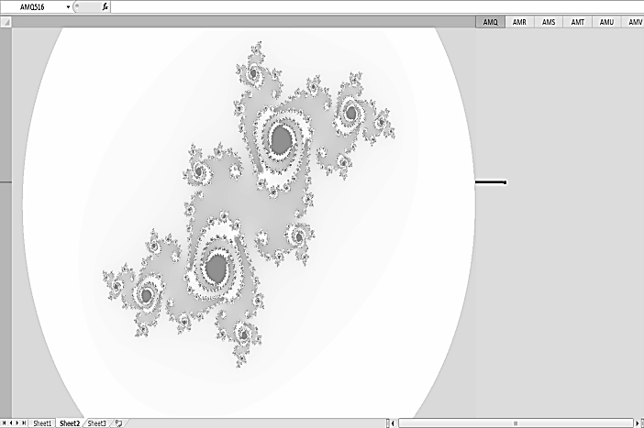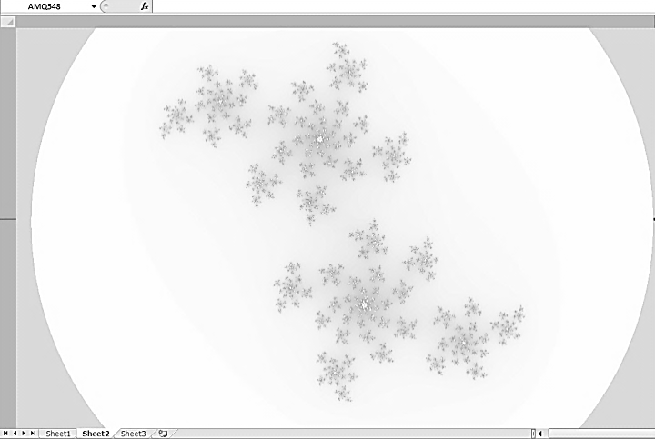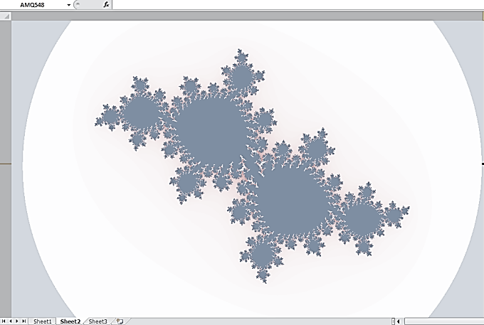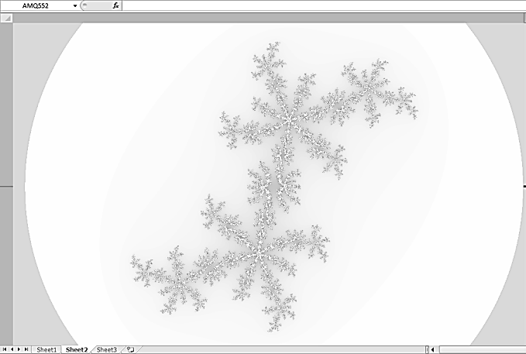

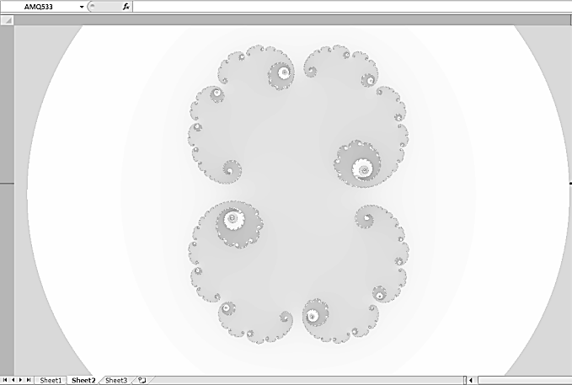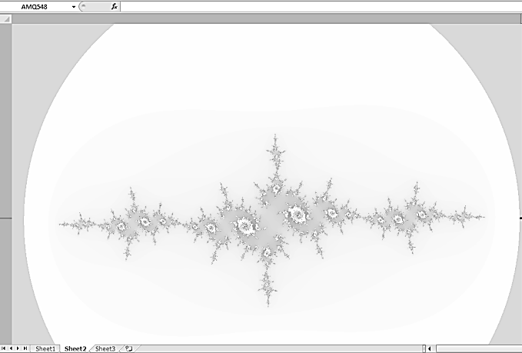

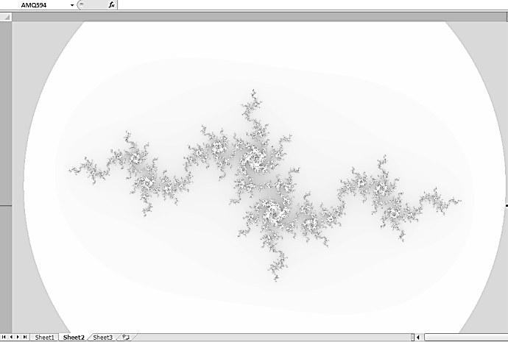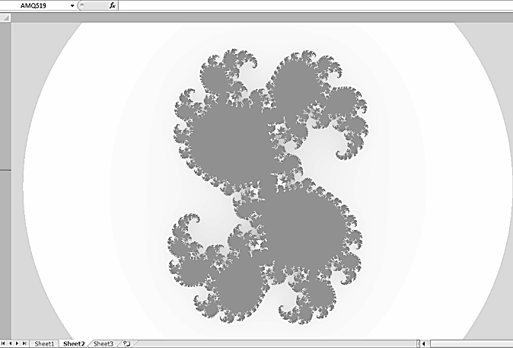

11.9 Buddhabrot
The Buddhabrot was discovered by Melinda Green, who adapted the classical Mandelbrot set algorithm to develop a new way of displaying it. Lori Gardi named this rendering the "Buddhabrot".
In the classical approach, each pixel goes through the Mandelbrot formula. A point can escape or not escape after a certain number of iterations. The pixel is then plotted.
In the Buddhabrot approach, one selects points in the sample area of the complex number plane (-2 to 2 in both x and y direction, for example). The Mandelbrot formula is used without plotting to test if the point escapes to infinity or not.
- if the point does not escape, one choses another random point (i.e. the points inside the Mandelbrot set are ignored)
- if the point escapes, the iterated formula is run a second time, and all the intermediate points are plotted
Melinda's method is to choose random points from the sample area, Lori Gardi proposed to use an ordered grid to step though the sample area,

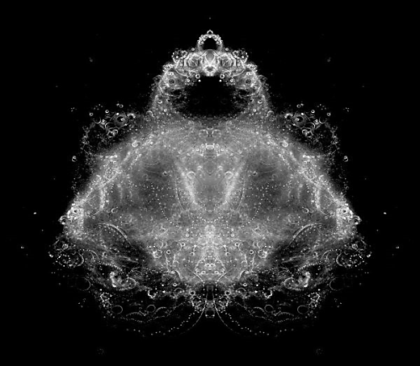

11.10 Summary
Mandelbrot set is a collection of points in the complex-number plane. Mandelbrot demonstrated the visual beauty of mathematical formula and thus made mathematics more approachable and interesting. What Mandelbrot did is close to miraculous as attested by millions of posters, greetings cards and T-shirts, bought by people who had not the faintest idea of what it was. In this chapter we have shown how to draw it in Excel and explore further. We have also seen related sets such as Julia sets and Buddhabrot

11.11 Exercises
1. Modify the Excel setup in Experiment No:1 to dynamically change the surface plot according to change in modulo operation. (start with modulo 2 and then increase to higher numbers)
2. Do the same(as in exercise No 1) for Julia set.
3. Implement Buddhabrot in xcel
11.12 References
[1] GNU Xaos:Fast interactive fractal zoomer, http://wmi.math.u-szeged.hu/xaos/ doku.php
[2] Mandelbrot Images http://warp.povusers.org/snaps/fract/
[3] Fractint freeware fractal generator http://spanky.triumf.ca/www/fractint/fractint.html
[4] 3D Mandelbrot set, http://www.skytopia.com/project/fractal/2mandelbulb.html
[5] Buddhabrot http://scienceblogs.com/goodmath/2007/07/the_mandelbrot_set_1. php
[6] Melinda Green http://www.superliminal.com/fractals/bbrot/bbrot.htm
http://en.wikipedia.org/wiki/Buddhabrot
[7] Source code for many fractal programs : https://www.fractalus.com/downloads/ source/
